Khrystian Clark

CS 325, Assignment 7

22FEB2022

Assignment: Graph Algorithms – I

*Note: The problem 2 is to be discussed as part of the Group Assignment. (Check*

*this week’s Group Assignment on Canvas for details).*

*The questions asked in this assignment – code implementation and time complexity of your code should be done individually based on the problem-solving strategy discussed within your group.*

1. **Write BFS and DFS for a graph**: What would be BFS and DFS traversal for the below graphs. Write the nodes for BFS and DFS. Start at node A.

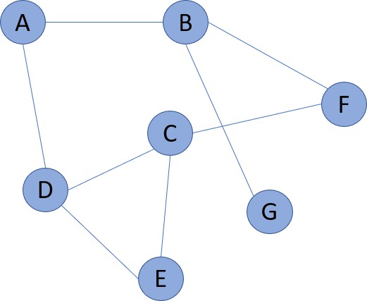

* BFS: A B D F G C E
  + Start: A🡪B D
  + B 🡪F G (taking away the front B)
  + D 🡪 C E (taking away the front D)
* DFS: A B F C D E G
  + A 🡪 B 🡪 F 🡪 C 🡪 D 🡪 E 🡪 Since all that left is G

1. **Apply BFS/DFS to solve a problem**

You are given a 3-D puzzle. The length and breadth of the puzzle is given by a 2D matrix puzzle[m][n]. The height of each cell is given by the value of each cell, the value of puzzle[row][column] give the height of the cell [row][column]. You are at [0][0] cell and you want to reach to the bottom right cell [m-1][n-1], the destination cell. You can move either up, down, left, or right. Write an algorithm to reach the destination cell with minimal effort. How effort is defined: The effort of route is the maximum absolute difference between two consecutive cells.

If a route requires us to cross heights: 1, 3, 4, 6, 3, 1

The absolute differences between consecutive cells is: |1-3| = 2, |3-4|=1, |4-6|=2,

|6-3|=3, |3-1|=2; this gives us the values: {2, 1, 2, 3, 2}. The maximum value of these absolute differences is 3. Hence the effort required on this path will be: 3.

Example:

Input: puzzle[][] = [[1, 3, 5], [2, 8, 3], [3, 4, 5]]

Output: 1

Explanation: The minimal effort route would be [1, 2, 3, 4, 5] which has an effort of value 1. This is better than other routes for instance, route [1, 3, 5, 3, 5] which has an effort of 2.

|  |  |  |
| --- | --- | --- |
| 1 | 3 | 5 |
| 2 | 8 | 3 |
| 3 | 4 | 5 |

* 1. Implement the algorithm. Name your function **minEffort(puzzle)**; puzzle will be in the form of an 2D matrix as shown in the above example. Name your file **MinPuzzle.py**
     + **See approach code in MinPuzzle.py file**
     + **Using DFS:**
       - **minEffort(puzzle)**
         * **startpoint = puzzle[0][0]**
         * **path list = [] #create a holder list for the path we will return**
         * **counter = 0 #create a count placeholder for the amount of “effort” we have.**
         * **Directionally compare which next placement would take more effort.**

**If (puzzle[m+1][n]-puzzle[m][n]) > (puzzle[m][n+1]-puzzle[m][n])**

**nextPoint = puzzle[m][n+1]**

**add nextpoint to path**

**increment counter with (puzzle[m][n+1]-puzzle[m][n])**

**If (puzzle[m+1][n]-puzzle[m][n]) < (puzzle[m][n+1]-puzzle[m][n])**

**nextPoint = puzzle[m+1][n]**

**add next point to the path**

**increment counter with (puzzle[m+1][n]-puzzle[m][n])**

**(need to come up with the case if they are equal)**

**Add the placement to the**

* + - * + **Repeat until we reach the bottom right cell (puzzle[m-1][n-1])**
        + **Return path list and counter.**
  1. What is the time complexity of your implementation?
     + O(|V| + |E|)

1. **Analyze Dijkstra with negative edges**: Analyze with a sample graph and show why Dijkstra does not work with negative edges. Give the sample graph and write your explanation why Dijkstra would not work in this case.
   1. **You run the risk of the algorithm not recognizing the negative value and/or producing the incorrect value as the optimal path.**
   2. **See below: The algorithm would be tricked and not recognize Y connection to Z because it would see the negative value as less than zero.**

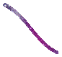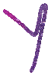

1. **(Extra Credit): What would be BFS and DFS traversal in below puzzle. Start at node A.**

|  |  |  |  |
| --- | --- | --- | --- |
| A | B | C |  |
|  |  | D | E |
|  | F | G |  |
|  | H | I | J |

* BFS: A B C D E G F I H J
  + Choosing the next at the most shallow depth/staying on the most convenient level.
* DFS: A B C D G I J H F E
  + Deepest first, then the adjacent.